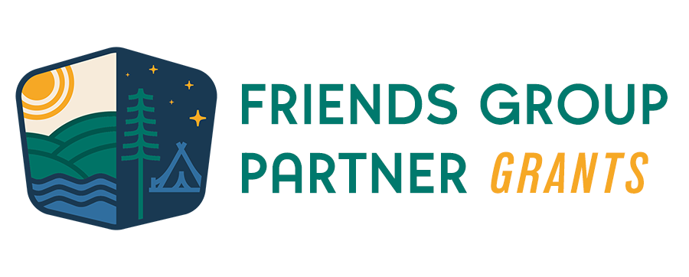

Field Trip Grants – Application

Directions: This application should be filled out and submitted to the Friends Group. Please answer each question thoroughly. Friends Groups are encouraged to submit a draft application for feedback to the Friends Group Program Manager by July 19, 2024. The final application with supporting materials should be submitted to friends@parksandtrails.org by 5pm on August 2, 2024.

Friends Group Name

Financials & Budget
Please fill out the Excel Budget Worksheet and submit with the application.
Grant Amount Requested (up to $1,000)

Our Friends Group is: (Place an “X” by those that apply.)
A 501(c)(3) nonprofit
A fiscal client of P&TC
Neither a 501(c)(3) nonprofit nor fiscal client of P&TC

Project Overview
Include a description of the project, including intended scope and scale.

Primary Grant Partnership
Identify your primary partner for this grant, how you intend to collaborate with that partner, and the youth demographic they serve.

Please also indicate the number of youth who will be engaged by this project.

Project Timeline
Project Timeline: Provide a timeline that delineates the anticipated time windows of each step in the process, including planning meetings, obtaining materials, facilitating events, etc. (i.e. ordering materials to be delivered by September 1, field trip happening in October, etc.).

Date/Month | Activity | Responsibility
e.g. September | Order materials and pick up from stores | Grant project committee
TBD | Interim Report due (project halfway point)
TBD | Field trip date

Past Experience(s)
Has the Friends Group implemented a project like this before? If so, please describe.

Partners
As a part of the application, please include a letter (or email) from the land management agency showing support for your group’s efforts in the project laid out in the application. A template is available on page 6.
Please indicate with which partners your group intends to collaborate by placing an “X” and identifying their name, role, and partnership status.
 |  |  | Partnership Stage
X | Partner Type | Partner Name | Exploratory *  (x) | Developing**  (x) | Established ***  (x)
 | Land management agency
 | Community organization
 | Business
 | Youth group
 | School
 | Other
* Aware of this group as a potential partner, but very limited discussion of partnership has occurred.
** Discussions have begun and/or the groups have partners on limited projects in the past.
*** Groups regularly partner on projects

Anticipated Impact
Discuss short- and long-term impacts that the project would have on the youth, the Friends Group and the park or trail.

Potential Barriers
What’s the biggest barrier to the implementation of this project, and how does your group plan to address it?

Project Leadership
Main Friends Group Project Contact
Name
Email |  | Phone
Secondary Friends Group Project Contact
Name
Email |  | Phone

Submission
Date application submitted
Submitted by

This document, along with the budget and letter, can be submitted as attachments in an email to friends@parksandtrails.org. Applications are due by August 2nd, 2024 at 5pm.

Date

Parks & Trails Council of Minnesota
275 E. 4th St., #250
St. Paul, MN 55101

To Whom It May Concern:

I am writing in support of a [project name (i.e. youth engagement, school field trip)] project for which [friends group] is planning. The project entails [description of the project].

This project complements existing initiatives at [park or trail] by [how it complements]. [Friends Group] has demonstrated capacity to implement this project by [how they demonstrate capacity].

Sincerely,

[Signature]

[Name]
[Role]
Division of Parks and Trails
Minnesota Department of Natural Resources

